Harvest!  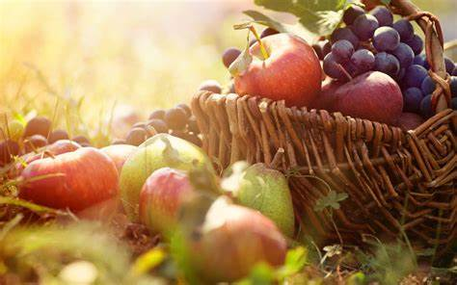  Autumn 1  Year 2 | Assessment  Write the initials of the child next to each objective to show the level that they are working at.
Can I… | Working  Towards | Expected | Exceeding
- Sing expressively in unison to an audience
- Respond to music by giving creative ideas
- Identify the rest and beat of a piece of music
- Identify and understand what a crochet and quaver is

End Points – Autumn 1 | Assessment  Write the initials of each child to show the level that they are working at.
 | Working Towards | Expected | Exceeding
Can I perform to an audience?
Can I confidently explain what a crochet and quaver is?
Can I confidentially express my opinions of a piece of music?

The 4 Elements of Success:
- Performing and Playing
- Listening and Evaluating
- Understanding and Exploring
- Create and Compose

Please write the initials of each child next to each objective to show what level they are working at for each objective. This is the same for the end points.

