**History Policy**

**Intent**

At Havannah Primary School our intention within History, is to develop within our pupils a deep sense of chronology and an appreciation of the significance of individuals within the shaping of our History.

Our curriculum will nurture a deep sense of inquisitiveness and ingenuity within our pupils and enable children to make connections and transfer skills and knowledge to a variety of learning opportunities. Our uniquely creative curriculum will inspire our pupils, stimulate their curiosity about the past and encourage investigation and critical thought

The aims of the History curriculum at Havannah Primary School are:

* To promote positive attitudes and enthusiasm for History
* To gain a sense of chronology that weaves throughout the curriculum, understanding how historical figures and events relate to each other across time.
* To ensure the progressive development of historical concepts, knowledge, skills and attitudes
* Know and understand the history of the UK as a coherent, chronological narrative, from the earliest times to the present day: how people’s lives have shaped this nation and how Britain has influenced and been influenced by the wider world
* Know and understand significant aspects of the history of the wider world: the nature of ancient civilisations; the expansion and dissolution of empires; characteristic features of past non-European societies; achievements and follies of man kind
* Gain and deploy a historically grounded understanding of abstract terms such as ‘empire’, ‘civilisation’, ‘parliament’ and ‘peasantry’
* Understand historical concepts such as continuity and change, cause and consequence, similarity, difference and significance, and use them to make connections, draw contrasts, analyse trends, frame historically valid questions and create their own structured accounts, including written narratives and analyses
* Understand the methods of historical enquiry, including how evidence is used rigorously to make historical claims, and discern how and why contrasting arguments and interpretations of the past have been constructed.
* Gain historical perspective by placing their growing knowledge into different contexts, understanding the connections between local, regional, national and international history; between cultural, economic, military, political, religious and social history; and between short- and long-term timescales.

**Implementation**

History is taught in blocks throughout the year, so that children achieve depth in their learning. The subject leader has identified the key knowledge and skills of each topic and consideration has been given to ensure progression across topics throughout each year group across the school. Historical concepts are taught and linked to each other through examining, **People, Power, Place in History and Purpose**. These common themes are introduced in Key Stage one and feature in each unit across Key Stage 2. Through these themes Children will understand how the past has informed subsequent periods of History and consequently their own lives. By the end of year 6, children will have a chronological understanding of British History from the Stone Age to the present day. They will be able to draw comparisons and make connections between different time periods and their own lives. Interlinked with this are studies of world History, such as the ancient civilisations of Greece and the Egyptians. Year 6 investigate more modern periods of History and consider the impact that these have had on modern life. Historical skills also play an important role enabling children to investigate Historical periods and analyse the past. These key skills are divided into; chronological understanding, range and depth of historical understanding, interpretation, enquiry and organisation and communication and are taught in a progressive way across year groups and units of work.

Cross Curricular links are made explicit through shared topic themes and all subjects have planned their curriculum based on a series of core ideas and intentions.

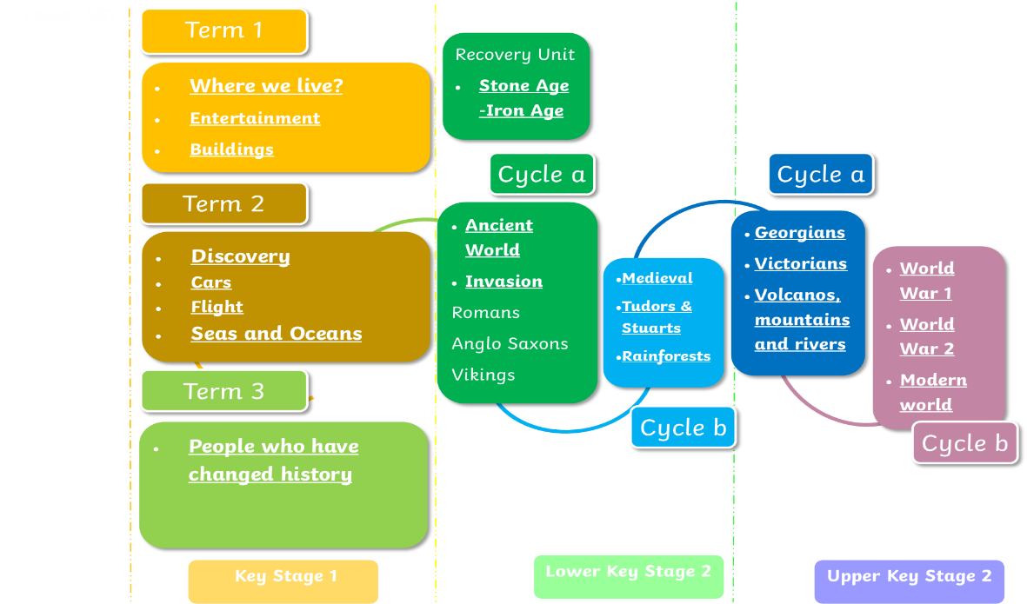

The local area is also fully utilised to achieve the desired outcomes, with extensive opportunities for learning outside the classroom embedded within practice. Planning is informed by and aligned with the national curriculum with a particular emphasis on chronology, making historical links between periods and the impact of key historical figures.

We achieve this by:

* Setting common tasks which are open-ended and can have a variety of responses
* Skill progression is identified within planning and through outcomes
* Setting tasks of increasing difficulty
* Planning across year groups to ensure progression of skills
* Grouping children by ability in the room and setting different tasks for each ability group
* Providing resources of different complexity depending on the ability of the child
* Using classroom assistants to support children individually or in groups.
* Clearly identified questions make links between units and historical periods.

**History Curriculum**

The National Curriculum defines the content of the school curriculum for history:

**Foundation Stage**

We teach History in the foundation stage as an integral part of the topic work covered during the year. We relate the History element of the children’s work to the objectives set out in the Educational programmes within the EYFS revised Curriculum (2021), which underpin the curriculum planning for children aged three to five. History makes a significant contribution to the ELG through within the Understanding of the World strand, developing a child’s knowledge and understanding of the world through their own lives and family. Within EYFS children explore their own timeline and events significant to them and their families. The concept of growth and change provide opportunity to explore themselves and their own development. A wide range of quality texts enable practitioners to explore the sense of self, family and timelines of events, anchoring understanding to children’s own memories.

**Key Stage 1**

Pupils will be taught about the past, using common words and phrases relating to the passing of time. They will learn where the people and events they study fit within a chronological framework and identify similarities and differences between ways of life in different periods. They will be taught a wide vocabulary of everyday historical terms. Children will ask and answer questions, choosing and using parts of stories and other sources to show that they know and understand key features of events. They will study some of the ways in which we find out about the past and identify different ways in which it is represented. Children begin to understand the concepts of the key questions within KS1, looking at **people and place in history** in year 1 and **power and purpose** in year 2. The content within KS1 focuses on introducing children to the concept of history through comparing their lives to those of their parents and grandparents. Looking at the changes within entertainment, houses, cars and then travel the children will explore change and the impact of that those changes. In additional the children will be introduced to ‘change makers’ that have had a significant impact on history, these will be revisited later in KS2.

**Key Stage 2**

Pupils will continue to develop a chronologically secure knowledge and understanding of British, local and world history, establishing clear narratives within and across the periods they study. They will note connections, contrasts and trends over time and develop the appropriate use of historical terms. They will regularly address and sometimes devise historically valid questions about change, cause, similarity and difference, and significance. Children will construct informed responses that involve thoughtful selection and organisation of relevant historical information.

**Equal Opportunities**

All teaching and non-teaching staff should ensure that all pupils, irrespective of gender, ability, ethnicity and social circumstances, have access to, and make the greatest progress possible, in all areas of the curriculum. History provides opportunities for teaching that reinforces this ideal. Special Educational Needs Children with special educational needs are taught the full history curriculum which is tailored by their teacher to meet their needs. Some children may receive additional support to help them take a full and active role in history lessons. Tasks will be adapted if necessary to help children to succeed and reach their potential. See Special Education Needs Policy for more details.

**Assessment, Record keeping and Reporting**

Children will be assessed in History based on 2 key threads. Firstly, through responses to the 4 P questions in the form of cold (initial assessment) and hot (at the end of units) tasks. These tasks and the use of these questions throughout the unit will enable teachers to establish progress based on the key knowledge and understanding focus of the unit. The responses to these questions will also establish whether those key links across the History curriculum have been made. The second strand is the assessment of the key skills within each unit. These are divided into; chronological understanding, range and depth of historical understanding, interpretation, enquiry and organisation and communication. The identified key skills will be assessed at the end of each unit and recorded in order to show which pupils have not yet demonstrated the skill and those which have exceeded.

**Impact**

Outcomes and end points in History books link to key questions and children build answers through carefully planned units. Pupils review their knowledge throughout a sequence of lessons and place it within a timeline which develops throughout their primary career. Pupils are able to make links within their learning and across historical periods building understanding of substantive concepts and understanding of disciplinary knowledge. Pupil voice reflects an understanding of how our past builds our future and has directed impacted their own lives. Our History curriculum also demonstrates progression across key skills: enquiry, chronology, investigation, interpreting, making connections and communication.

**Monitoring and review**

The history subject leader is responsible for:

* Monitoring the standard of the children’s work and the quality of teaching and learning in History
* Reviewing and contributing to teacher's planning to ensure full coverage of the National Curriculum through the topic units taught
* Supporting colleagues in the planning, teaching and assessment of History
* Ascertaining pupil voice through interviews and discussions
* Informing colleagues about current developments in the subject, providing advice and maintaining the availability of resources and the history curriculum budget.
* Evaluating the strengths and weaknesses in the subject and highlighting areas for further improvement on the school action plan.

Monitoring of the subject will take part termly and will involve:

* Planning and book scrutiny
* Interviews with pupils
* Conversations with staff
* Learning walks
* Checking assessments are up to date