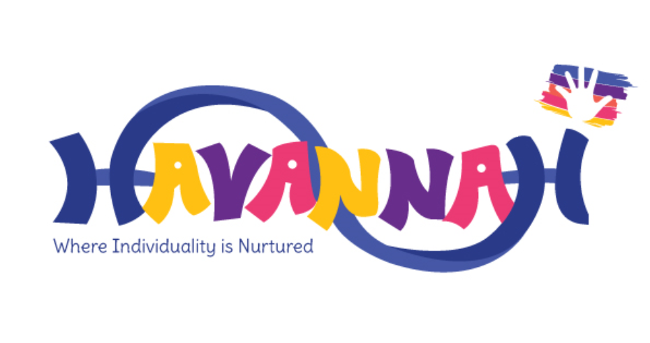

Early Years Foundation Stage
Policy

Value Statement

At Havannah Primary School the children in Pre-School and Reception are cared for and provided with a stimulating and challenging environment, which enables them to have the best possible start to school. Both settings are fully inclusive, respects and values cultural diversity and is sensitive to all children’s needs. In partnership with the family and carers, we supply a wealth of opportunities for children to begin the process of becoming active learners. Through play-based learning and exploration, children grow into creative and critical thinkers for life.

“Every child deserves the best possible start in life and to fulfil their potential. A child’s experience in the Early Years has a major impact on their future life chances. “

Department for Children, Schools and Families 2012

Principles

The EYFS is based upon four guiding principles:

A unique child. We recognise that every child is a competent learner who can be resilient, capable, confident and self‐assured. We recognise that children develop in individual ways and at varying rates. Children’s attitudes and dispositions to learning are influenced by feedback from others; we use praise and encouragement as well as celebration and rewards to encourage and develop a positive attitude to learning.
Positive relationships. We recognise that children learn to be strong and independent from secure relationships and aim to develop caring, respectful and professional relationships with the children and their families.
Enabling environments. We recognise that the environment plays a key role in supporting and extending the children’s development. Through observations, we assess the children’s interests, stages of development and learning needs before planning challenging and achievable activities and experiences to extend their learning.
Learning and development. The EYFS is organised to allow children to explore and learn securely and safely. There are areas where the children can be active, be quiet and rest. The unit is set up in learning areas where children are able to find and locate equipment and resources independently.
“The first three years are the most critical in shaping the child's brain architecture. Early experiences provide the base for the brain's organizational development and functioning throughout life. They have a direct impact on how children develop learning skills as well as social and emotional abilities.”
UNICEF

At Havannah Primary School we greatly value the importance that the EYFS plays in laying secure Early Years for future learning and development. It is important to view the EYFS as preparation for life and not simply preparation for the next stage of education.

The Early Years Foundation stage (EYFS) for children is from birth to five years of age. All children begin school with a wide variety of experiences and learning and it is the privilege of the adults working in the Early Years stage to building upon that prior learning. This is done through a holistic approach to learning ensuring that parents and guardians, support staff and the Early Years Stage team work effectively together to support the learning and development of the children in their charge.

The Unique Child

In our school we believe that all our children matter. We give our children every opportunity to achieve their best. In the Early Years Foundation Stage, we set realistic and challenging expectations that meet the needs of our children. We achieve this by planning to meet the needs of boys and girls, children with special educational needs, children who are more-able, children with disabilities, children from all social and cultural backgrounds, children of different ethnic groups and those from diverse linguistic backgrounds.

We meet the needs of all of our children through:
- planning opportunities that build upon and extend children’s knowledge, experience and interests, and develop their self-esteem and confidence;
- using a wide range of teaching strategies based on children’s learning needs and styles;
- providing a wide range of opportunities to motivate and support children and to help them to learn effectively;
- providing a safe and supportive learning environment in which the contribution of all children is valued;
- using resources which reflect diversity and are free from discrimination and stereotyping;
- planning challenging activities for children whose ability and understanding are in advance of their language and communication skills;
- monitoring children’s progress and taking action to provide support as necessary. This involves speech therapy for some of our children;
- working alongside a range of adults within our setting and from outside agencies who can provide specialist knowledge and support for children with additional social, emotional, behavioral and educational needs such as our school SENCO, Early Years Special Needs Advisors and Speech Therapists.

Positive Relationships

We believe that parents are the child’s first educator and that all have an important role to play in the education of their child. Parents are made to feel welcome and valued in their dealings with all members of staff. We recognise the role that parents have played, and their future role, in educating the children. We do this through:
- talking to parents about their child before their child starts in our school in the form of home visits;
- the teacher visits children in their Playgroup or Nursery setting prior to their starting school;
- the children have the opportunity to spend time with their teacher before starting school in what we call ‘Stay and Play’ sessions;
- inviting all parents to an induction meeting during the term before their child starts school;
- arranging for children to gradually be introduced to the school over the first week of term. We encourage parents to stay if there are problems with the child’s admission;
- offering parents regular opportunities to talk about their child’s progress in our Reception class;
- encouraging parents to talk to the child’s teacher if there are any concerns. If needed, a meeting will be set up between the staff and parent/carer so that any issues can be resolved quickly.
- a weekly mystery reader which encourages parents, carers and other family members to come in and read to the class;
- regular newsletters and notes from school which keep parents ‘in the loop’ with events and opportunities in Pre-School and Reception and throughout the rest of the school. These are also available on the school’s website;
- having flexible admission arrangements that enable children and parents to become familiar with the school;
- arranging a range of activities throughout the year that encourage collaboration between child, school and parents;

Both Pre-school and reception offer extensive opportunities for home school communication through Facebook groups, Word press blogs and Class Dojo, these support the strengthening of the relationships that are so key in the early years.

Formal meetings for parents in the Autumn, Spring and Summer term at which the teacher and the parent discuss the child’s progress in private with the teacher. Parents will receive a termly progress report chart so parents have a clear indication of where their child is and progress that has been made. Parents receive a full report on their child’s attainment and progress at the end of each school year.

Enabling Environments

At Havannah Primary School we recognise the environment plays a key role in supporting and extending the children’s development, where the children feel confident, secure and challenged. The children have daily access to an indoor and outdoor environment that is set up in discrete areas of learning with planned continuous provision.

Play-based learning is paramount and children have opportunities to direct their own learning with planned opportunities provided by staff.

We plan and create a learning environment, both indoors and outdoors, that encourages a positive attitudes to learning and reflects the individual’s interests, passions and abilities. We use materials and equipment that reflect both the community that the children come from and the wider world. We encourage the children to make their own selection of the activities on offer, as we believe that this encourages independent learning.

Learning and Development

The Early Years Foundation Stage Curriculum
Our early year’s settings follow the statutory curriculum requirements as outlined in the latest version of the EYFS statutory framework that applies from September 2021. We offer a broad and balanced curriculum that covers the statutory aspects as well as other knowledge and skills to support pupils’ personal development, prepare pupils for their next stage of education and develop the whole child. The EYFS framework includes 7 areas of learning and development that are equally important and interconnected. However, 3 areas known as the prime areas are seen as particularly important for igniting curiosity and enthusiasm for learning, and for building children’s capacity to learn, form relationships and thrive.

The EYFS Curriculum – Our curriculum for the Foundation Stage reflects the areas of learning identified in the Early Learning Goals.

The areas of learning included are split into two different areas; prime areas and specific areas.
The prime areas begin to develop quickly and support the other areas of learning:
Personal, Social and emotional development
Communication and Language
Physical Development
The specific areas include essential skills and knowledge and provide contexts for learning:
Literacy
Mathematics
Understanding of the World
Expressive Arts and Design
The Development Matters document and the Early Learning Goals provide the basis for planning throughout the EYFS. Long term planning is flexible and based upon both general topics for the whole school and the EYFS.

Characteristics of effective learning

The characteristics of effective learning underpin achievement of these prime and specific areas of learning. They describe factors which play a central role in a child’s learning and in becoming an effective learner and are vital elements of support for the transition process from EYFS to Year 1. The characteristics represent processes rather than outcomes. Information describing the child’s characteristics of effective learning will provide Year 1 teachers with vital background and context when considering the child’s next stage of development and future learning needs.
Playing and exploring – engagement
  - Finding out and exploring
  - Playing with what they know
  - Being willing to ‘have a go’
Active learning – motivation
  - Being involved and concentrating
  - Keeping trying
  - Enjoying achieving what they set out to do
Creating and thinking critically – thinking
  - Having their own ideas
  - Making links
  - Choosing ways to do things

Our Teaching and Learning policy defines the features of effective teaching and learning in our school. These features apply to teaching and learning in the EYFS just as much as they do to the teaching in KS2. It includes whole class teaching and working with small groups or individuals. Teaching and Learning in the Foundation Stage also includes planned, purposeful play which is a mixture of adult led and child initiated. We advocate that play is essential for children’s development and that adults should take time to explore and play with the children on a daily basis.

Play in the Early Years Foundation Stage

“Play is essential to development as it contributes to the cognitive, physical, social, and emotional well-being of children.”

“Play allows children to use their creativity while developing their imagination, dexterity, and physical, cognitive, and emotional strength. Play is important to healthy brain development. It is through play that children at a very early age engage and interact in the world around them.”
Kenneth R. Ginsburg

At Havannah Primary School, we do not make a distinction between work and play. Children learn through planned and spontaneous play activities. Staff provide opportunities for child-initiated and adult-led play as well as independent and guided play opportunities.

Through play, our children explore and develop learning experiences, which help them make sense of the world. They practice and build up ideas, gain confidence as they explore and develop essential social and communication skills. Children are given the opportunities to investigate and discover within a safe and supported environment. Play underpins the delivery of the EYFS curriculum.

The children have the opportunity to think critically and creatively alongside other children and are given time to reflect on problems and are encouraged to find their own solutions. They communicate with others as they investigate and solve problems. Our children are involved with both group and individual play, which is initiated by both the adults and the children. They learn through being active learners working with a wide range of resources. Through play children will develop intellectually, creatively, physically, socially and emotionally. It gives children the opportunity to take risks and make mistakes.

Assessment

We make regular, on-going assessments of children’s learning, and we use this information to ensure that future planning reflects identified needs. Assessment in the EYFS is ongoing and is an integral part of the learning and development process. At the end of the EYFS each child’s level of development is assessed as meeting expected levels of development or, not yet reaching expected levels (‘emerging’) for each of the 17 Early Learning Goals. This provides parents and carers, practitioners and teachers with a picture of the children’s knowledge, skills. The EYFS staff also write a short commentary on each child’s skills and abilities in relation to the Key Characteristics of Effective Learning.

The Early Years staff make systematic observations and assessments of each child’s achievements, interests and learning styles. The observations and assessments are used to identify learning priorities and plan the next stages in the learning experiences for the child. The observations are then matched to the early learning goals and characteristics of learning and are collated in each child’s Learning Journey. The observations may take the form of photographs, examples of work or post-it type note observations. These assessments are mostly taken from child-initiated pieces of work in order to show a true picture of the child’s level of development. Adult led work can be used as supporting evidence and are located in the child’s books or Learning Journey.

The assessments contain a wide range of evidence that are shared with parents at each parental consultation meeting and inform our judgements in the end of year EYFS. The EYFS Profile is moderated at local level in Cluster groups and by LEA advisors.

Parents receive an annual report that offers brief comments on each child’s progress in each area of learning. It highlights the child’s strengths and development needs and gives details of the child’s general progress. We complete these in June and send them to parents in early July each year.

Safeguarding and welfare procedures

We promote good oral health, as well as good health in general, in the early years through our curriculum, for example by talking to children about:
• The effects of eating too many sweet things
• The importance of brushing your teeth
We also teach E-safety, relationship education and health education across our EYFS in age-appropriate ways.

The rest of our safeguarding and welfare procedures are outlined in our safeguarding policy.

Policy adopted: 2024 Summer
Policy review:

