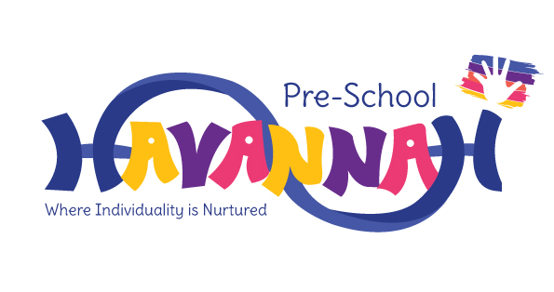

Havannah Pre-School Admissions Policy

Admission to the Pre-School is managed and controlled by Havannah Primary School Governing Body. Any parents or carers wishing to apply for a place for their child must complete the relevant application form and hand it in to the School Office (see Appendix 1). We aim to ensure that all sections of our community have access to the pre-school through open, fair and clearly communicated procedures.

Once a child has turned 3 they are eiligible for admission to Havannah Pre-School, subject to an application being made and places being available.

Admission to the Pre-School does not guarantee admission to the Reception class.

Admission Criteria
When the Pre-School is over-subscribed applications for entry will be ranked according to the following criteria:
- Looked after children and previously looked after children
- Exceptional social/medical need
- Children who have or will have a sibling that attends the pre-school or the main school at the time of admission
- Children who will turn 4 in the current academic year (this is to give priority to those children who will be due to transfer to the Reception class in the next academic year)
- The order applications were made to the school for a place
- Distance from the pre-school, according to the straight line distance that they live from the school, with priority being given to those who live closest to the school.

Headcount restrictions mean that no more than 26 children can attend the morning session and no more than 26 children can attend an afternoon session. Once we are over-subscribed, we will maintain a waiting list with children ranked according to the above criteria.

The Governing Body commits to ensuring that the existence of the Pre-School is widely advertised in places accessible to all sections of the community and that information about our Pre-School is accessible in both written and spoken form and, where appropriate, in different languages.

Procedures for Admission
To ensure we are providing our children with the best experience possible we commit to:
- enabling children to remain with us until the start of their Reception year;
- ensuring children must attend Havannah Pre-School for at least 2 sessions per week to ensure staff and children are given enough time to form a bond;
- welcoming children regardless of their gender, special educational needs, disabilities, background, religion, ethnicity or competence in spoken English. We will liaise fully with parents and professionals to ensure that it would be in the child/ren’s best interests to attend the group;
- encouraging parents/carers to have visits with their child/ren shortly before admission is due, and should be prepared to stay with their child/ren if necessary for this first session;
- operating a flexible admissions procedure and where appropriate a child may attend for brief periods at first; gradually building up to a full session;
- accepting Nursery Education Grants for children in the term following their 3rd Birthday to cover up to 5 sessions per week;
- being flexible about attendance patterns, wherever possible, to accommodate the needs of individual children and families;
- consider admission of a child who is a ‘rising 3’, during the term in which they turn 3. Any such offers will be considered dependent upon availability (this admission would be chargeable unless the child is eligible for FEET funding)

The school’s and the extended services equal opportunities policy is available on the school website;

Funding
Havannah Pre-School has committed to receive children who are eligible for the 30 hours funding. Once a child has turned 3 they can start to receive the funding the term after their 3rd birthday. 30 hour funding is available for families where both parents are working (or the sole parent is working in a lone parent family), and each parent earns the equivalent of 16 hours a week at the national minimum or living wage, and earns less than £100,000 a year. 30 hour funding provides the child with 30 hours of free childcare per week, over 38 weeks or the equivalent number of hours across more weeks per year.

If you family receives benefits then your child may be eligible to claim FEET. If you meet the eligibility criteria then you can apply for FEET the term your child turns two but you won’t receive the free hours until the following term. You can apply for FEET by completing the Cheshire East Council application form.

Allocation of a place
A place will only be offered to a child once the Governing Body is happy that a place can be offered in accordance with the admission criteria, detailed above. If an applicant is offered a place they must confirm acceptance directly with the school by the date stipulated in their offer letter. The final decision with regard to admission and allocation of places (Monday to Friday, morning or afternoon sessions), rests with the governing body of the school.

The school will endeavour to inform parents/carers of the outcome of their application by letter at least one term before admission.

Application to Reception class
Admission to the Havannah’s Pre-School does not guarantee admission to the Reception class at Havannah. Applications for Reception must be made on a separate application and submitted by the statutory deadline to Cheshire East Council in order to be considered (please see the School Admission Policy).

Complaints and Appeals
Any complaints regarding the admission process should be directed the Chair of Governors

